Product Update #1: Migration from Swift UI to ConfigHQ for Datafeed
Goal
- Decommission the legacy Swift UI interface for Datafeed.
- Fully migrate all Client Services and Implementation teams to use ConfigHQ.
Timeline
- Target Completion: January 2025
Why This Matters
- Strategic Simplification: Reduces platform sprawl by consolidating to a single interface — ConfigHQ — which supports the company's broader objective to transition clients to Kubra HQ, BizHQ+, and MyHQ+.
- Operational Efficiency: Eliminates the need to maintain and update both Swift UI and ConfigHQ, streamlining support and reducing tech debt.
FAQs
- What if I don’t have access to ConfigHQ?
  - Submit an access request via Helpdesk.
- Will Datafeed configurations from Swift UI appear in ConfigHQ?
  - Yes, configurations created in Swift UI will be visible in ConfigHQ.
  - Example:
    - Node Feed Name: 001-10-14-brit-ngrid DN Feed
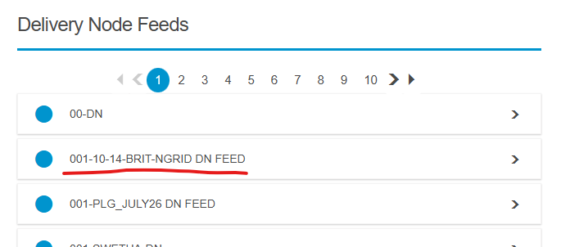
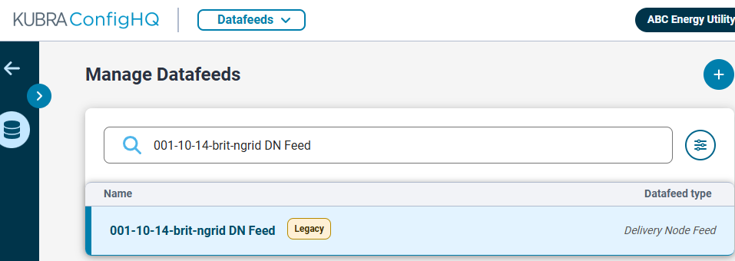

Product Update #2: Datafeed V3 Enhancements & Benefits
Overview
- Datafeed V3 maintains the same functionality as V1 but with significantly improved maintainability and deployment efficiency.
Client Impact
- Minimal Client Benefit: No major changes in features or behavior from a client-facing perspective.
- However, no further updates or support will be provided for Datafeed V1 going forward.

KUBRA Internal Benefits
- Accelerated Setup:
  - V1 setup could take several days due to duplicated codebases per feed type.
  - V3 setup is streamlined to ~30 minutes using centralized, single configuration files.
- Engineering Efficiency: Reduces manual engineering effort and simplifies future enhancements.

Additional Notes
- KRN (Kubra Resource Name) is now the standard identifier used in V3.
  - It's a unique identifier for referencing services on the KHQ platform.
  - For product team investigations, please include the following:
    - Datafeed Name
    - Version & Type
    - File Name & Upload Date
    - (If applicable) Datafeed KRN & Space KRN
FAQs
- Is there a timeline that V1 will be shutdown?
  - No.
- Will existing Datafeed V1 implementations be migrated to V3?
  - No, you will have to create.
- How do I know if I should use V1 or V3?
  - First check with the product person of that Datafeed type, Notifi/Storm Center.
- As a service delivery/implementation KUBRA employee, should I care about KRNs?
  - No.

